**AMETHYST**

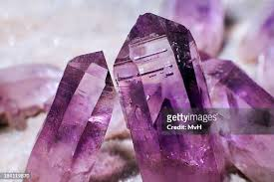  **Name:** Lavendar Amethyst

**Brand:**  Orrefors

**Model#:** 001

**Color:** Purple

**Price: $40 million**